**HOSPITAL MANAGEMENT SYSTEM**

**FOR**



Simplilearn Project

Submitted by: **Ved Pratap Chauhan**

**TABLE OF CONTENTS**

* Business analysis core concept model
* Requirement classification schema
* Stakeholders RACI Matrix
* Root cause analysis
* Present state process map
* Workflow of the proposed system
* Future State Process Map
* Data Flow Chart For HMS
* In scope and out scope requirement for the software
* Entity relationship diagram
* Mock up screen

**BUSINESS ANALYSIS CORE CONCEPT MODEL (BACCM)**

Conceptual Framework

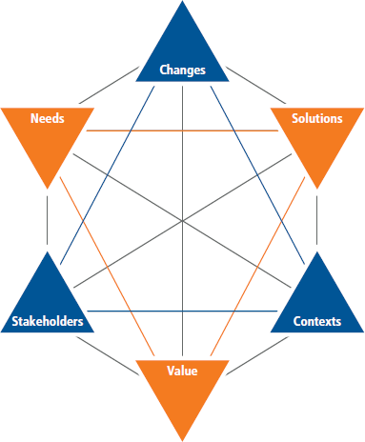

**BUSINESS ANALYSIS CORE CONCEPT MODEL (BACCM)**

**HOSPITAL MANAGEMENT SYSTEM**

|  |  |
| --- | --- |
| **Change** | * Switch from manual registration of patients to online management system. * System generating bill, collection of money and showcasing availability of bed for occupancy. * Effective management of medical reports |
| **Need** | * Hectic and tedious paper method for maintaining patient details. * Time consuming to get the details of a particular patient. * Chances of patient details getting misplaced. * Wire and tire of the paper documents. |
| **Solution** | * Design and implement hospital management system. * Integrating with patients’ registration, treatment history and the billing details. * Providing update option in the patients details and giving unique ID of each patient for easy access of their details. |
| **Stakeholders** | * Doctors * Administrative Staff * End User (Nurses, Receptionist) * Senior management * Pharmacist * Patients * IT Department * Laborites and Diagnostic Centre |
| **Value** | * Increase in efficiency in maintaining patients. * Satisfaction for the patients. * Decreased cost of all paper works. * Increasing the productivity of the staff members. * Hands on registration and updating for patients. * No mismanagement of details. |

**REQUIREMENT CLASSIFICATION SCHEMA**

|  |  |
| --- | --- |
| Business  Requirement | * Online hospital management system * Online registration of patient details * Billing and Collection of money in the system * Tracking of patient history and bed availability * Update option in patients’ medical history * Reduction in paper work |
| Stakeholders  Requirement | * Online management system * Option for report update * Easy tracing of patient’s medical history * Doctor’s instructions should be visible * Reports for revenue and expenses of the hospital. |
| Solution  Requirement | **Functional requirement: -**   * Patient registration * Report uploading (diagnoses, lab test) * History tracking and update * Generating bill * Bed occupancy * Unique ID for a particular patient * Report management system * User friendly interface * Interlinking of patients details and medical reports * Appointment reminder for patients * Medication and treatment record * Feedback system * MySQL   **Non-Functional requirement: -**   * Ensure device accessibility * Ensure internet accessibility * Increased server capacity and bandwidth * Access to uninterrupted power supply |
| **Transition**  **Requirement** | * User Training * Medical Staff Training * Doctors Training * Briefing by IT officials |

**STAKEHOLDERS RACI MATRIX MODEL**

Different level of Stakeholders involvement charts

|  |  |  |
| --- | --- | --- |
| **DESIGNATION** | **NAME** | **ROLE** |
| Business Analyst | A | A, R |
| Project Manager | C | A |
| Senior Doctor | D | C |
| IT Department Head | F | R |
| Medical Staff | E | R, C |
| Nurses | G | R |
| Medical Supplier | H | R |
| Pharmacist | N | R |
| Lab manager | P | A, R |
| Patients | O | I |
| Tester | U | R |

*R=Responsible, A=Accountable, C=Consulted, I= Informed

**THE ROOT CAUSE ANALYSIS**

The problem statement is represented in a flow diagram manner for better understanding of the cause and effect of the problem.

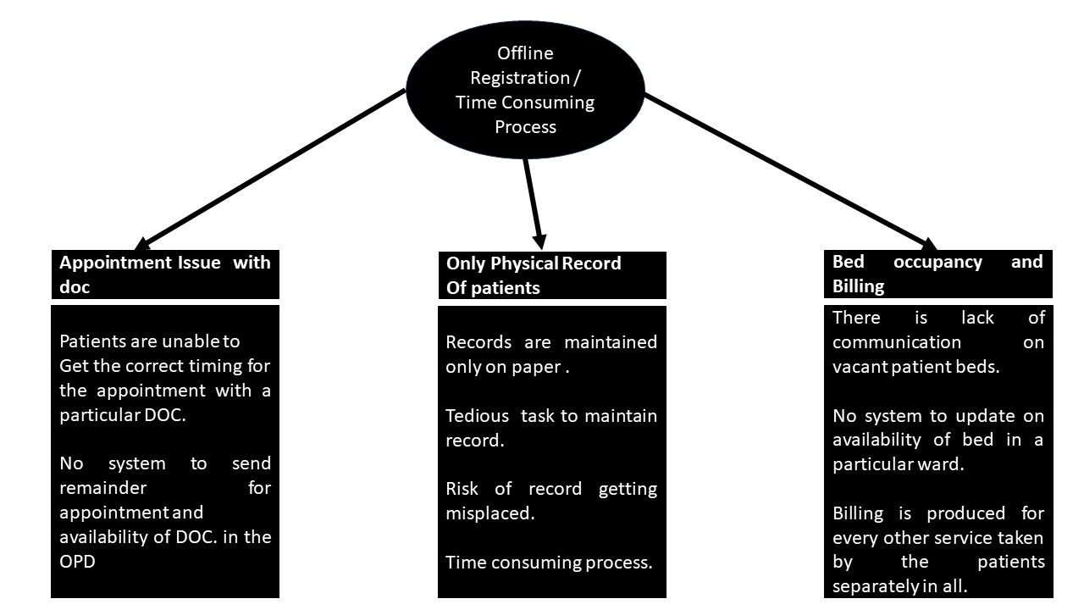

**THE PRESENT STATE OF THE HOSPITAL MANAGEMENT**

**SYSTEM**

The present system shows the current hospital

management system shown in flow diagram:-

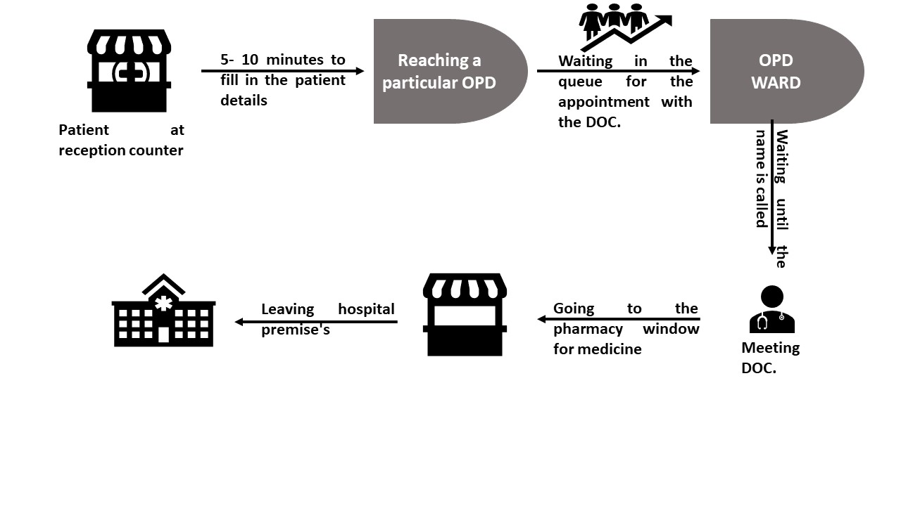

**WORKFLOW OF THE PROPOSED SYSTEM**

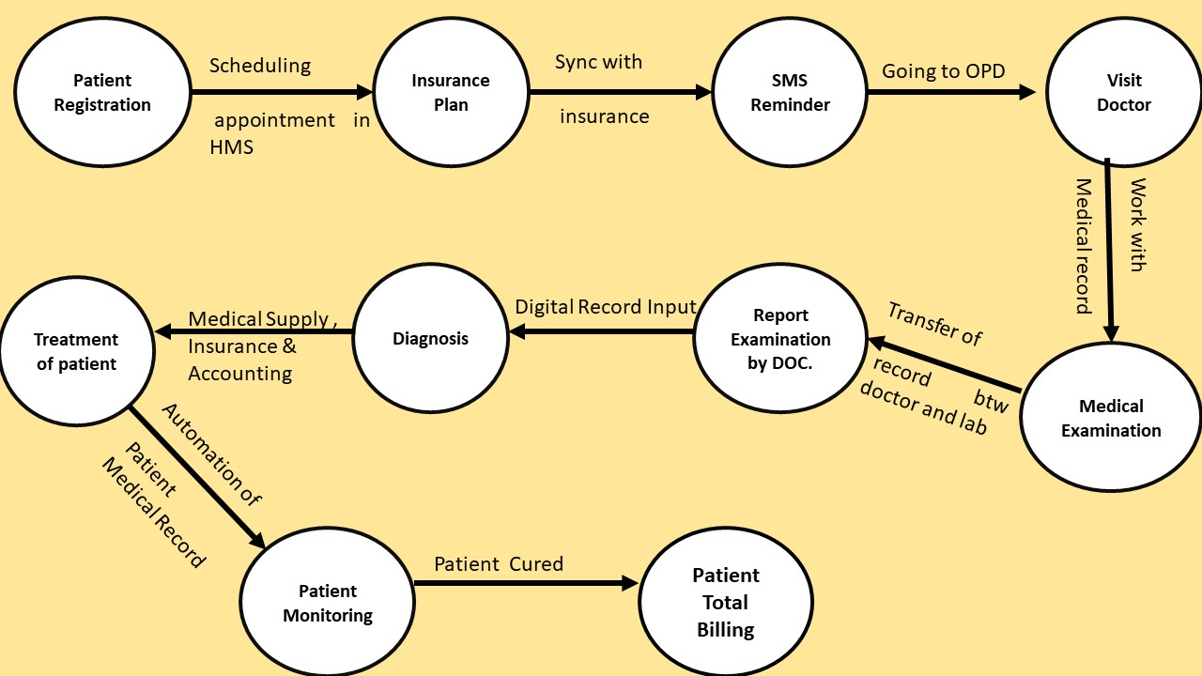

**FUTURE STATE PROCESS MAP**

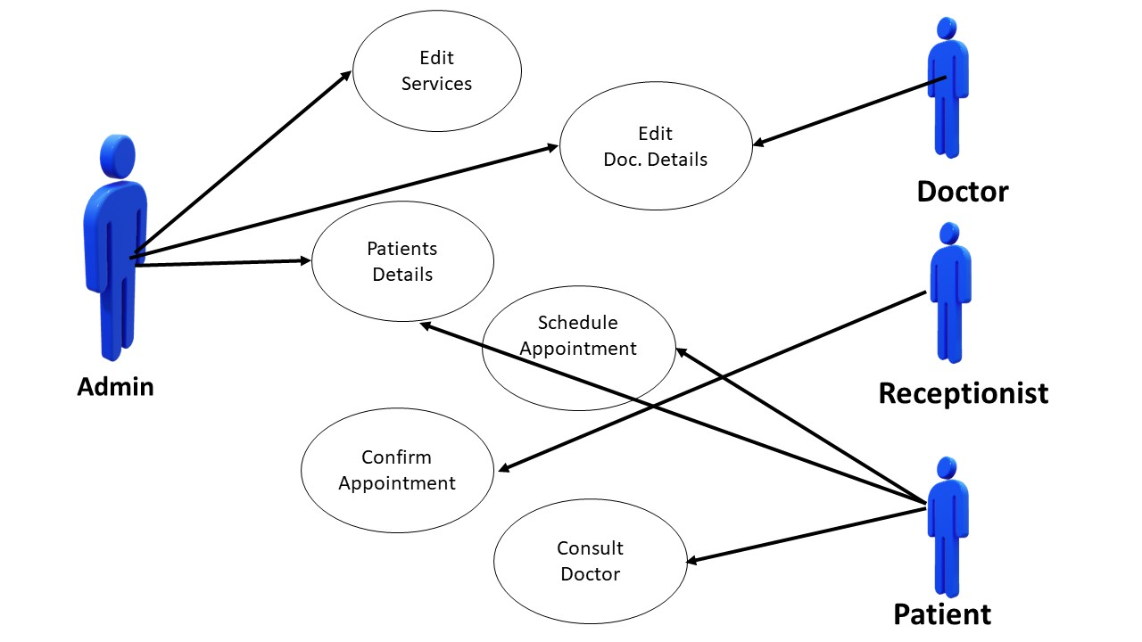

**Data Flow Chart for HMS**

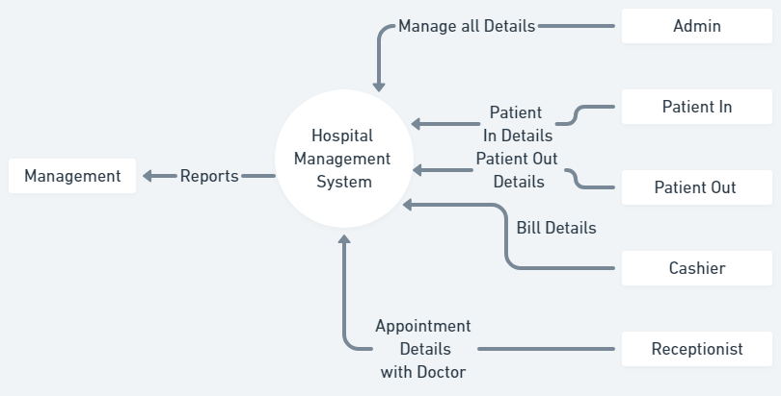

**INSCOPE AND OUTSCOPE REQIREMENT**

**OF THE SOFTWARE**

**In Scope Requirement**: -

Functional Requirement -

* **Patient Appointment Management**

Scheduling appointments for consultations.

Managing appointment availability for doctors.

Handling appointment rescheduling and cancellations

* **Appointment Reminders**

Sending automated reminders to patients via SMS, email, or calls.

Reminder notifications for upcoming appointments.

Alerts for missed or delayed appointments.

* **Patient Registration**

Collecting patient personal details, medical history, and contact information.

Assigning unique patient ID numbers.

Verifying patient insurance or payment details

* **Bed Occupancy**

Monitoring the availability of hospital beds.

Tracking bed assignments for admitted patients.

Managing bed transfers and discharge processes

* **Laboratory, Blood Bank, and Radiation Department Management**

Managing diagnostic tests and lab result reports.

Monitoring blood availability and managing requests in the blood bank.

Scheduling and tracking radiation treatments and procedures.

* **Reports**

Generating reports for patient data, treatment outcomes, and hospital performance.

Financial reporting for billing, payments, and revenue tracking.

Reports for inventory, bed occupancy, and department-specific performance

* **Staff Management**

Scheduling shifts and managing staff availability.

Tracking staff performance, attendance, and leave.

Managing payroll, benefits, and staff records.

Ensuring compliance with certifications and ongoing training.

* **Instructions for Patients**

Providing post-treatment or post-surgery care instructions.

Offering guidance on medication schedules and dosage.

Educating patients on follow-up care, diet, and exercise.

Offering resources for patient education (brochures, videos, etc.).

* **Insurance**

Verifying patient insurance details before treatment.

Handling insurance claims and documentation for various procedures.

Managing co-payments, deductibles, and patient out-of-pocket expenses.

Coordinating with insurance providers for approvals and reimbursements

* **Reporting to management:** -
* **Bed Occupancy for Each Day**

Daily report on the number of occupied and available beds.

Breakdown of bed usage by department or ward.

Trends in bed occupancy rates over time.

* **Doctors’ Appointments and Revenue Generated through OPDs**

Number of appointments per doctor for a given period.

Revenue generated from each doctor's consultations in the Outpatient Department (OPD).

Comparison of appointment numbers and revenue by doctor.

* **Total Number of OPD Patients and Admitted Patients**

Daily/weekly/monthly report on the total number of OPD patients.

Total number of admitted patients within the same period.

Trends and analysis of patient volume.

* **Which Doctors Generate Maximum Revenue**

Ranking of doctors based on revenue generation from consultations and procedures.

Analysis of revenue trends linked to each doctor's patient load.

* **Total Amount of Earnings through OPD and Admitted Patients**

Summary of earnings from OPD consultations.

Total revenue generated from admitted patients (inpatient treatments, surgeries, etc.).

Comparison of revenue streams between OPD and inpatient services.

* **Total Amount of Earnings Generated through Laboratory and Radiology**

Total revenue from laboratory tests and diagnostics.

Earnings from radiology procedures (X-rays, MRIs, CT scans, etc.).

Comparative analysis of revenue between lab and radiology departments

Non- Functional Requirement-

* **Ensure Device Accessibility:** Make sure that all necessary devices (computers, tablets, phones, etc.) are functional, properly configured, and easily accessible for users or employees.
* **Ensure Internet Accessibility:** Guarantee that internet access is stable, with consistent connectivity and high-speed performance, enabling smooth browsing, communication, and data transfer.
* **Increased Server Capacity and Bandwidth:** Upgrade server capacity and bandwidth to handle more data, ensuring faster load times, better performance, and the ability to accommodate more users simultaneously without slowdowns.
* **Access to Uninterrupted Power Supply (UPS):** Implement backup power solutions such as UPS systems or generators to ensure continuous operation of critical devices and infrastructure during power outages or fluctuations

**Out of Scope**:

* This system is for a single premise of The Mayo Clinic at Rochester.

**ENITITY RELATIONSHIP DIAGRAM**

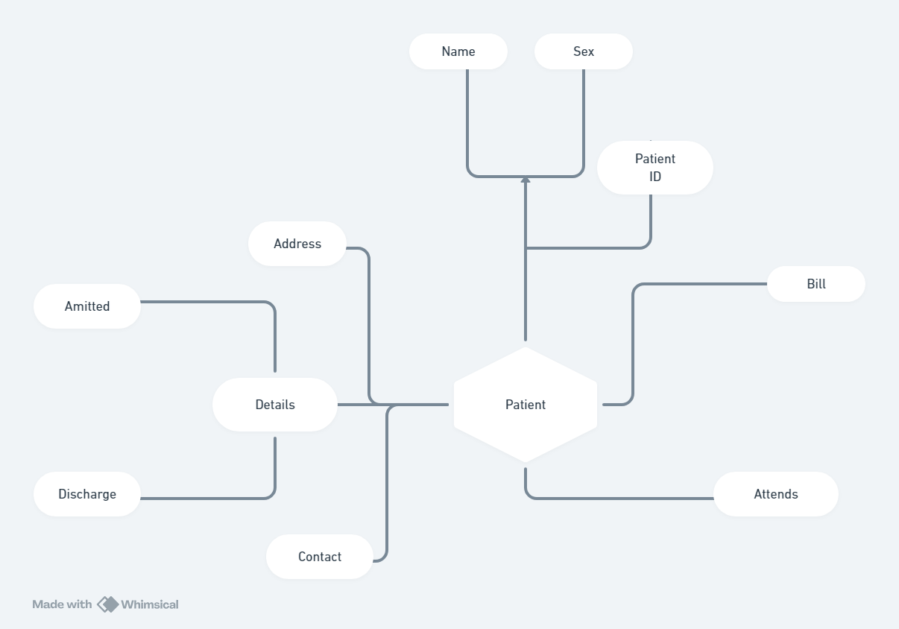

**MOCKUP SCREEN**

